**Assessment 7– EC2 and EBS**

**Trainee Name : Gargi Sharma**

**Mentor Name : Mr. Ravi Kumar**

**College Name : UPES**

1. Create an EC2 instance (Ubunutu 18.04, T3 nano).(instance A)

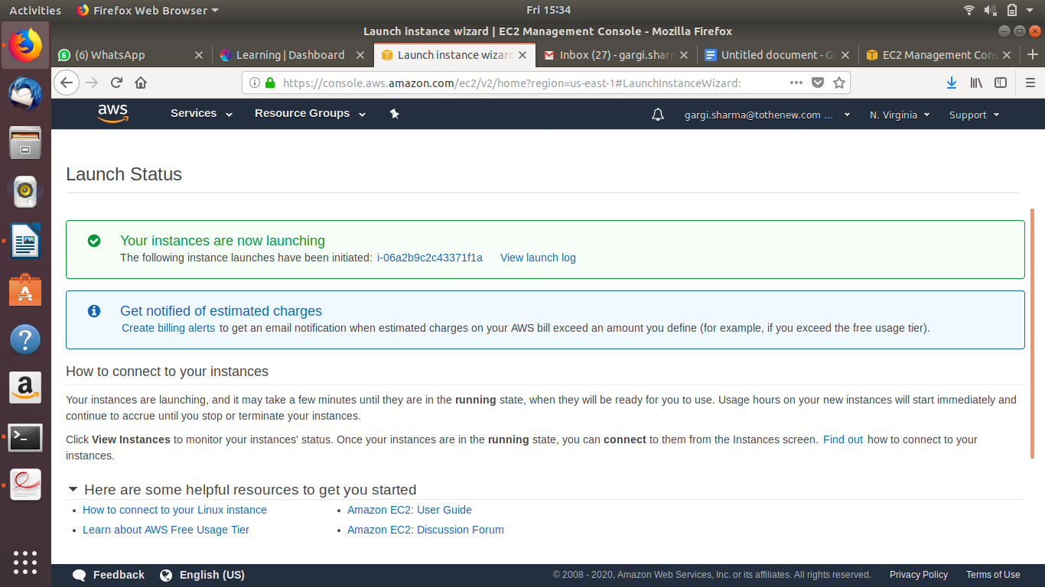

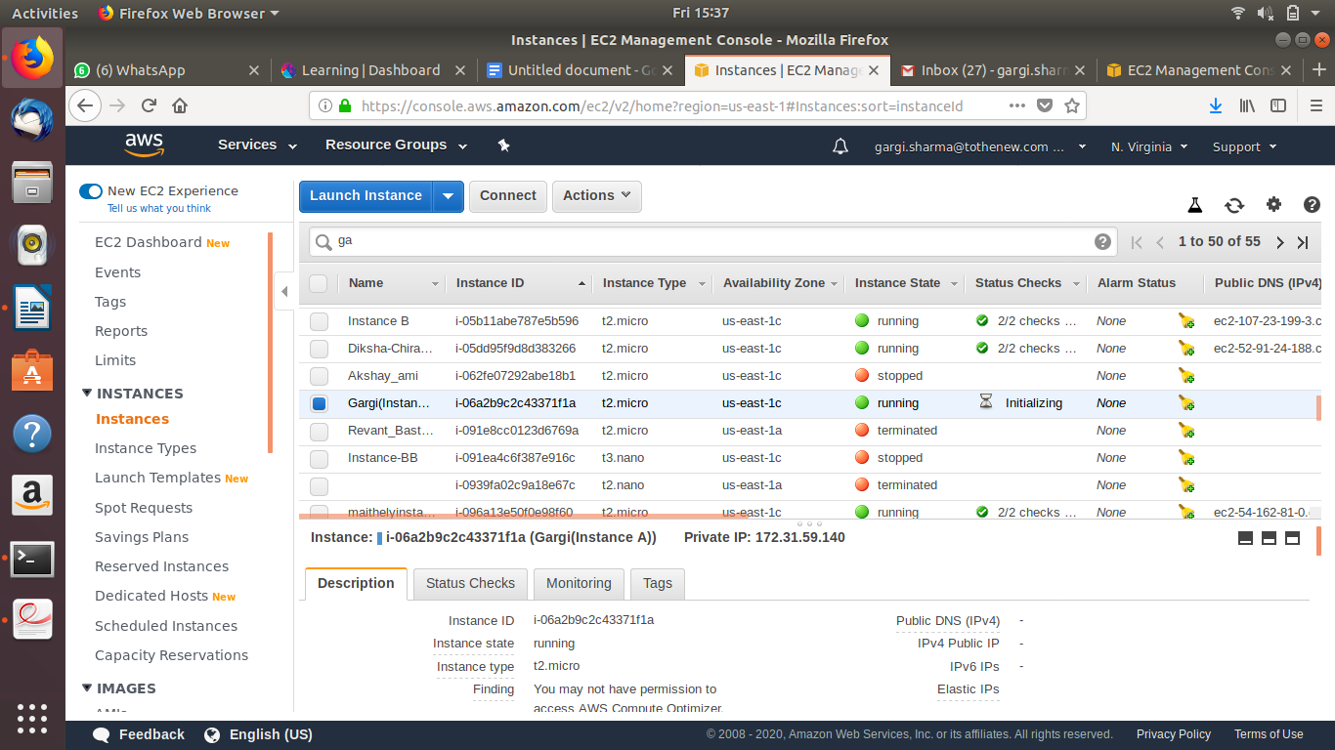

1. Create AMI of above instance and launch it. (instance B)

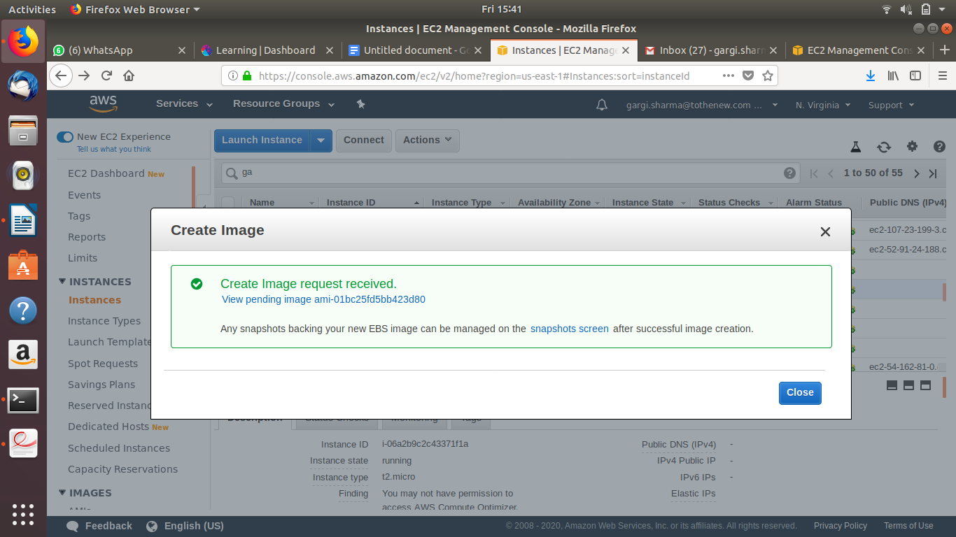

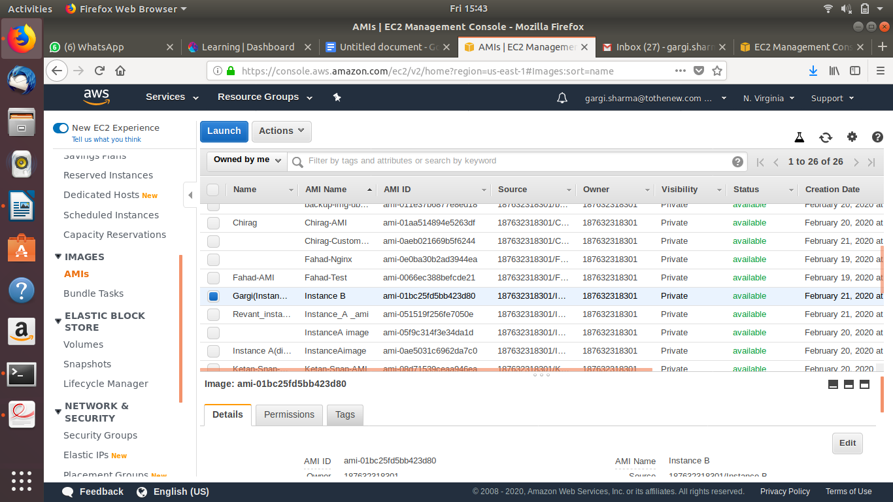

1. Attach EBS (8 GB) on that running instance.

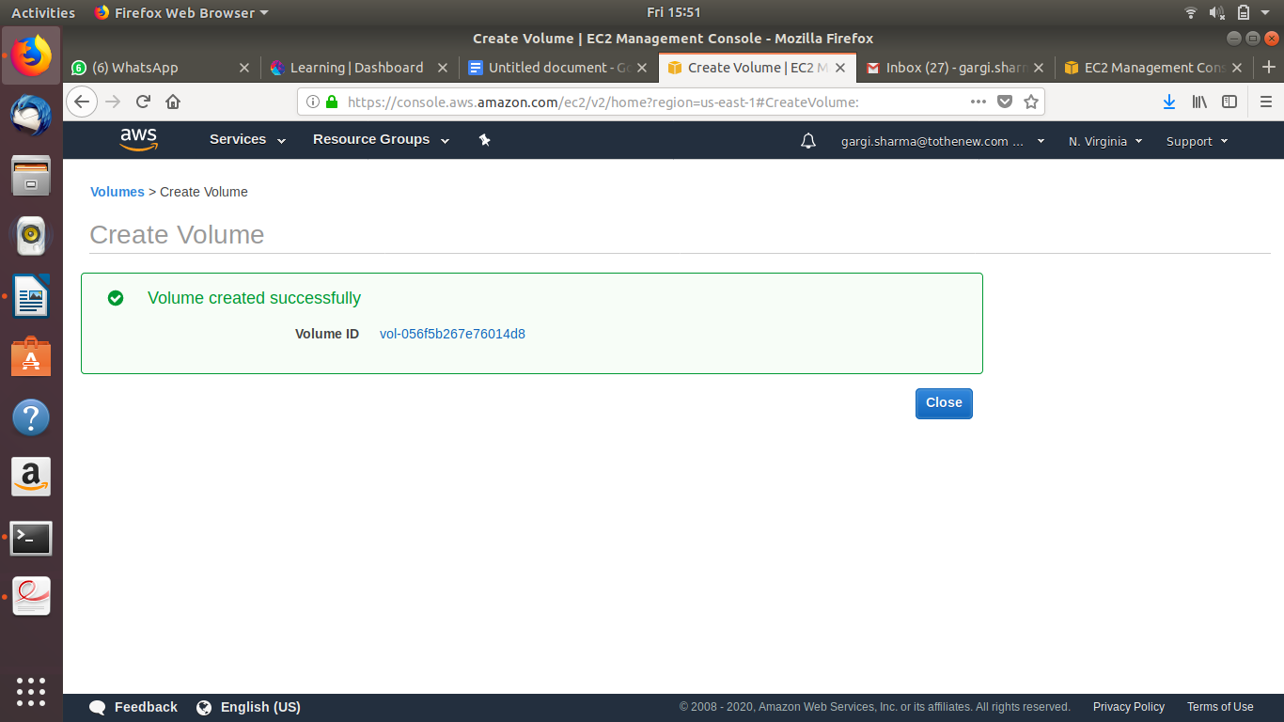

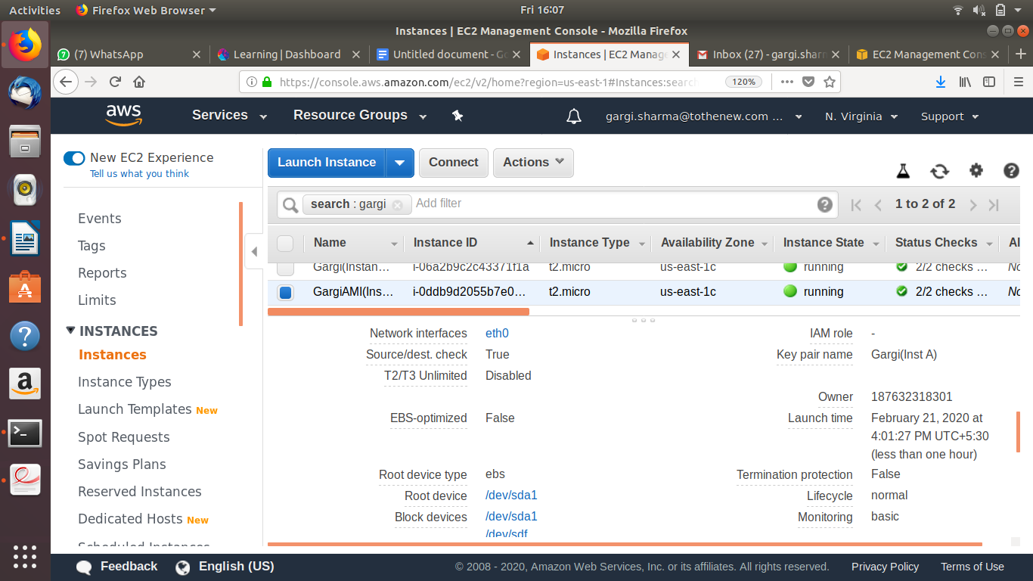

SSH into Instance B to mount the newly attached EBS:

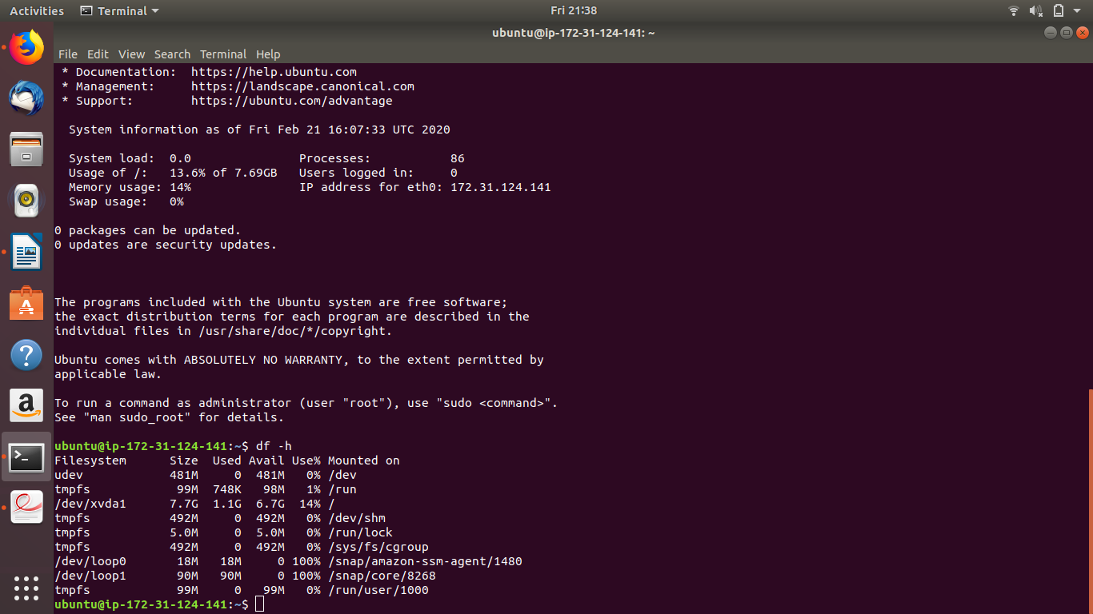

Create a filesystem : sudo mkfs -t ext4 /dev/xvdf

Create a directory to mount this EBS: sudo mkdir Volume

Mount the Filesystem: sudo mount /dev/xvdf /ubuntu/home/Volume

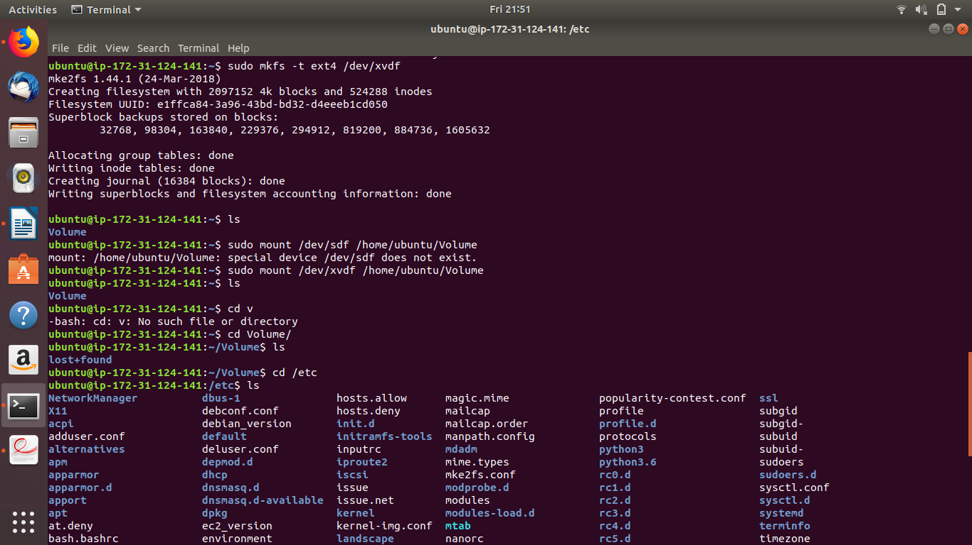

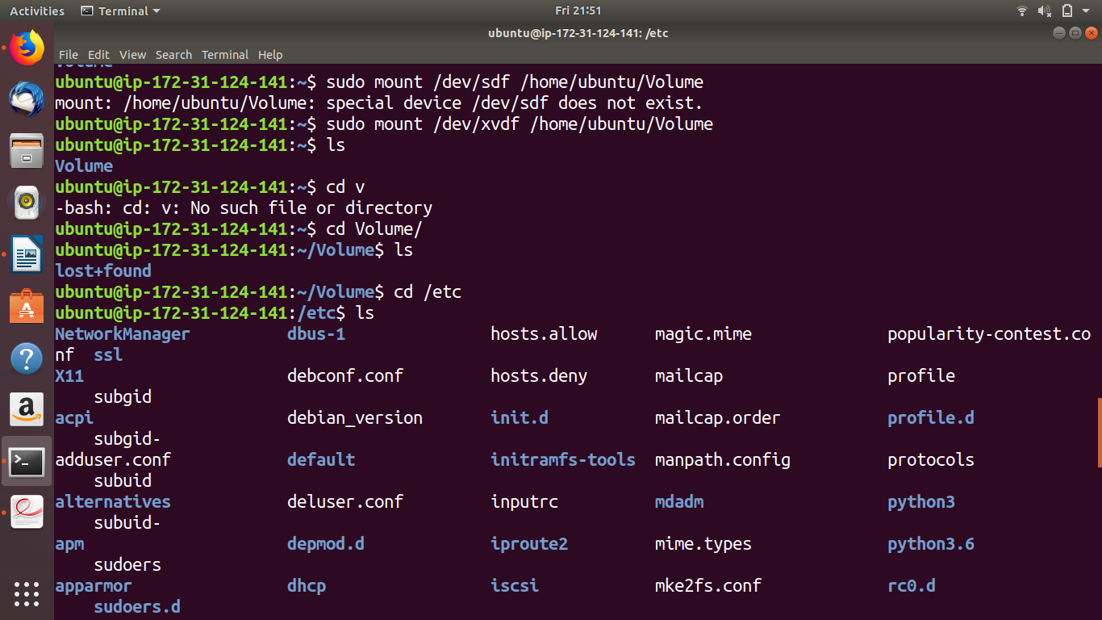

Do df -h to check the newly mounted filesystem

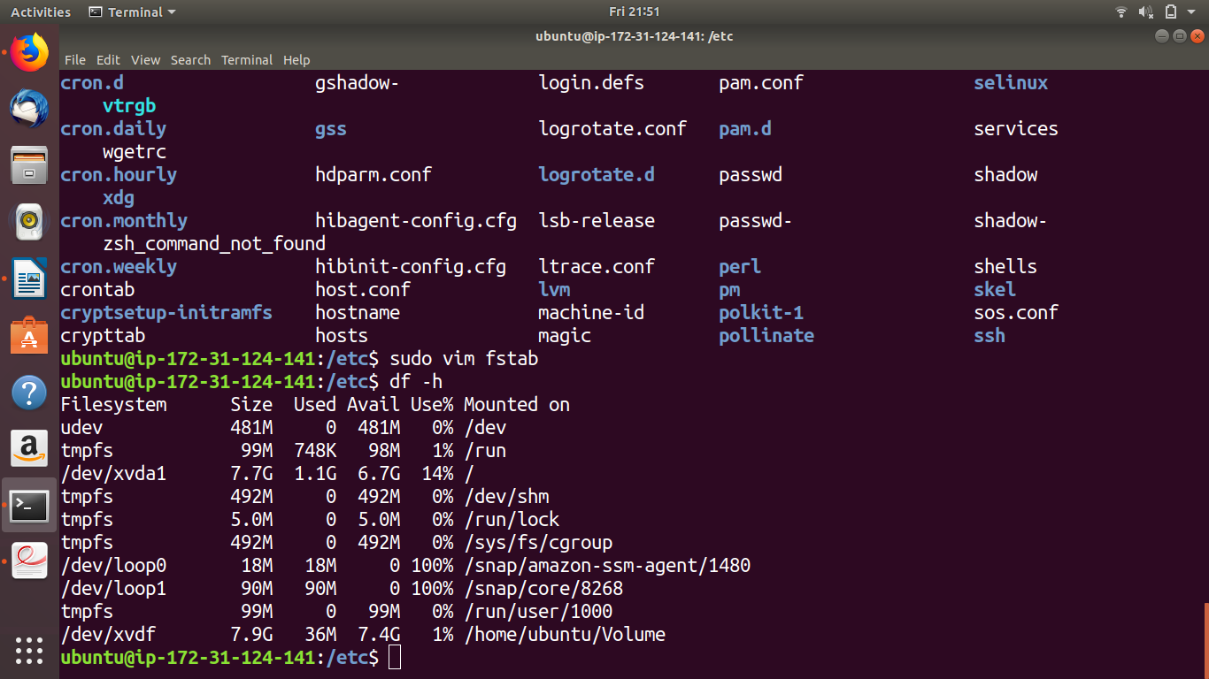

1. Stop, Start, Restart that EBS ( EBS must be auto-attached).

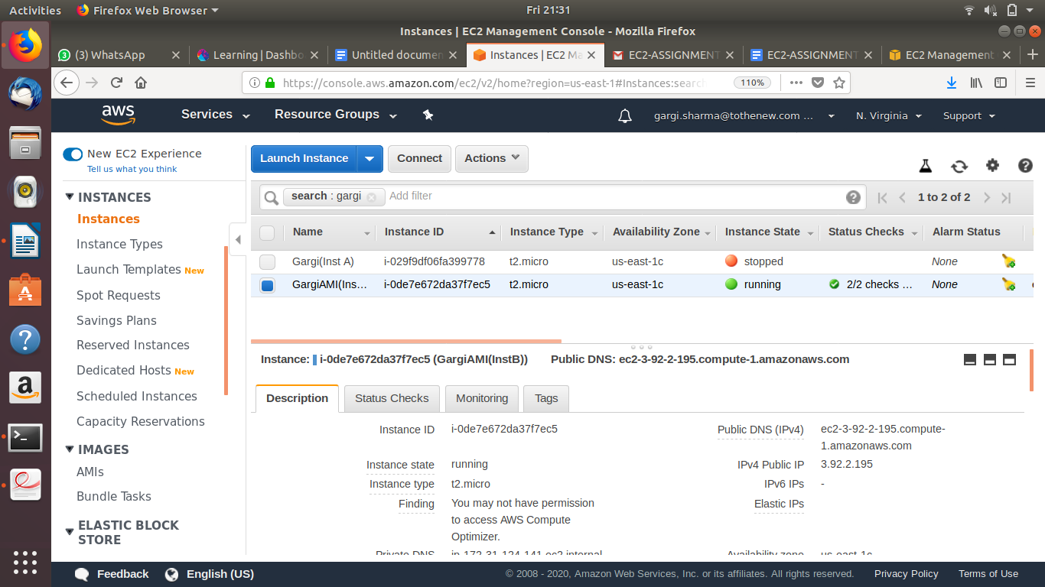

Restarting Instance (New IP gets allotted):

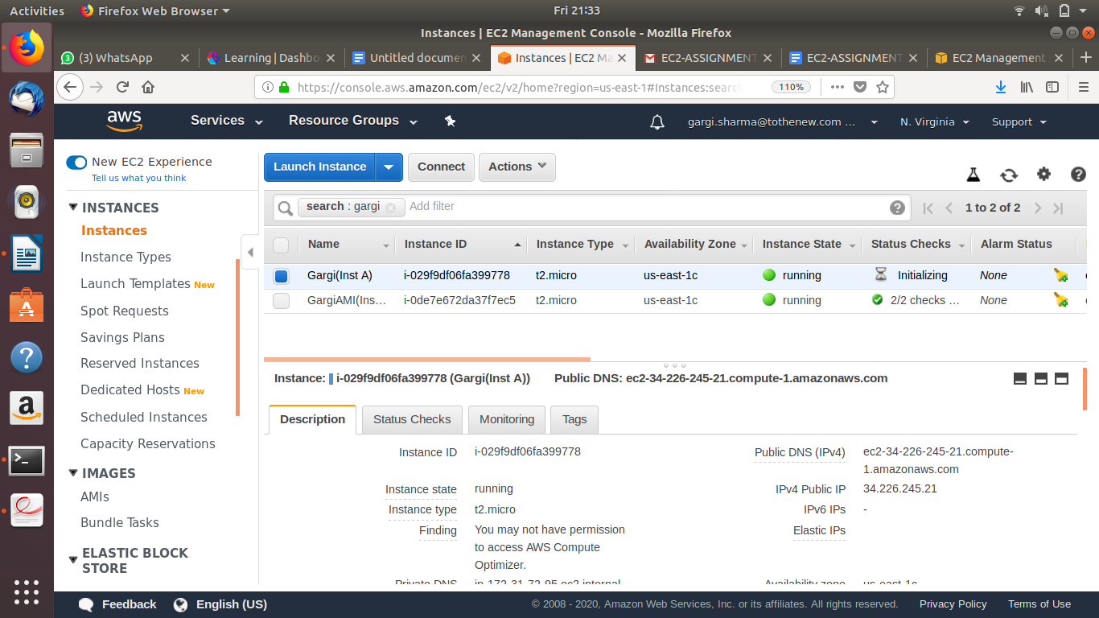

1. Make some mistake in fstab file, stop and start the instance, then troubleshoot it.

Cannot ssh in instance B due to error in fstab:

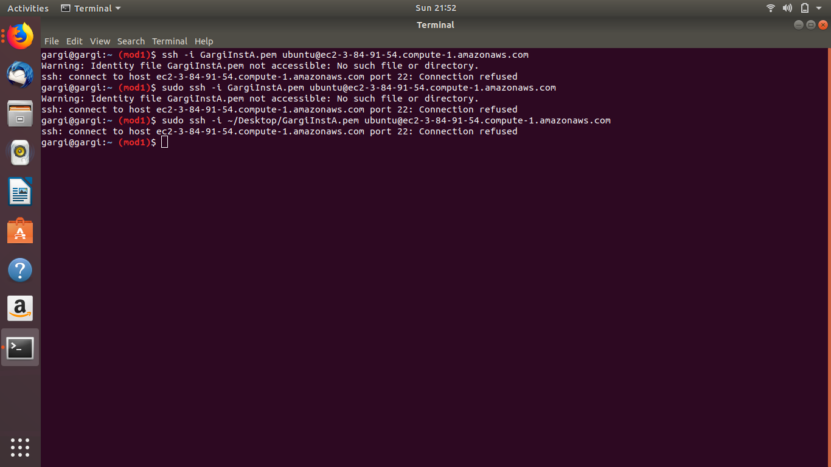

Create a maintainence instance:

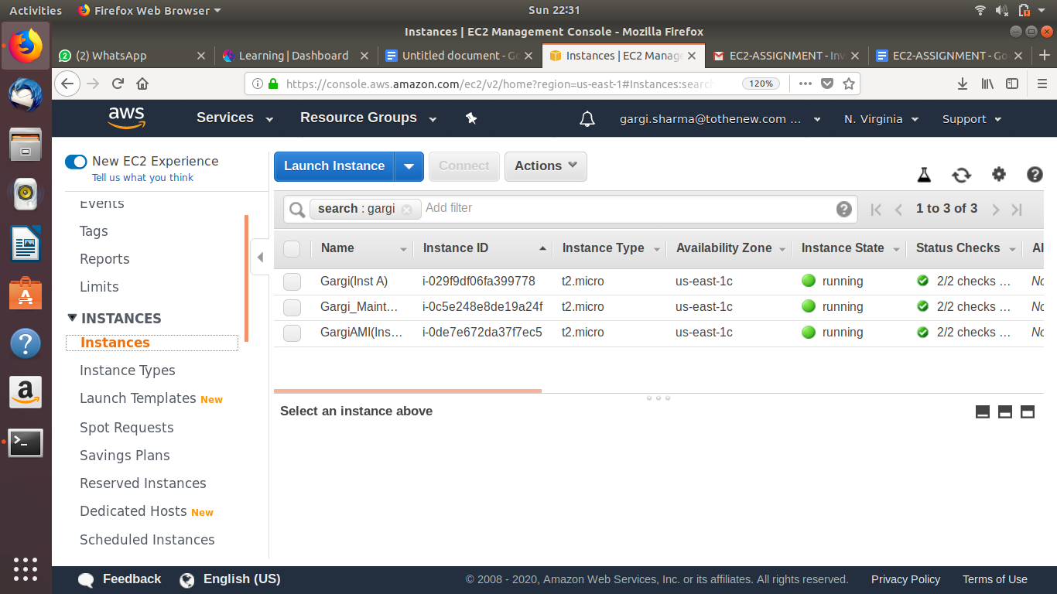

Detach the root volume from Instance B:

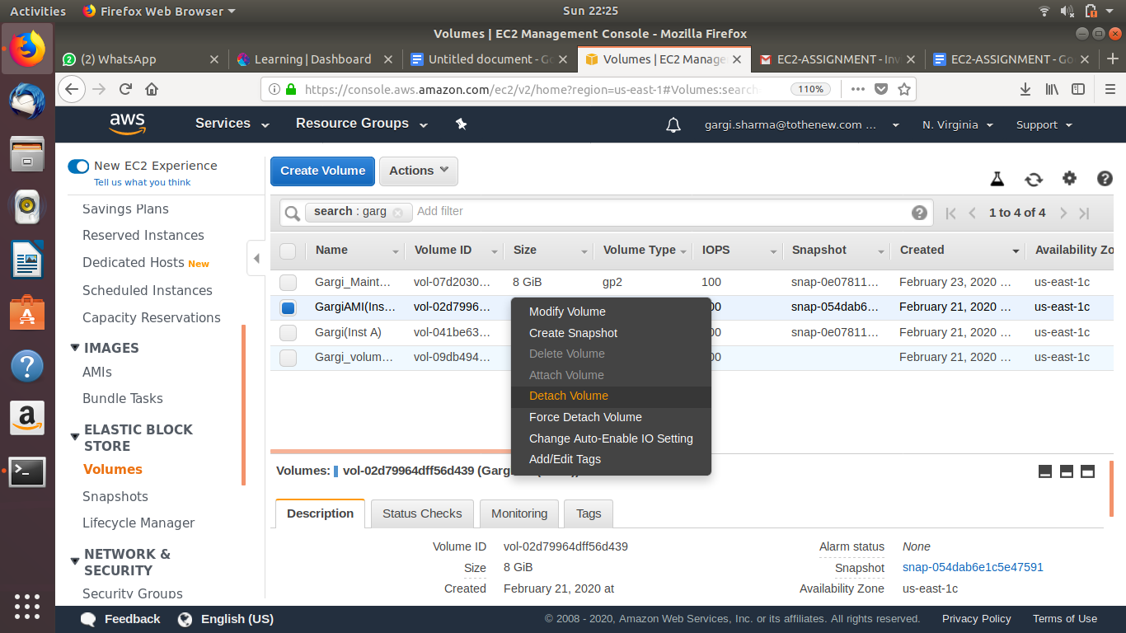

Attach the root volume to Maintenance Instance:

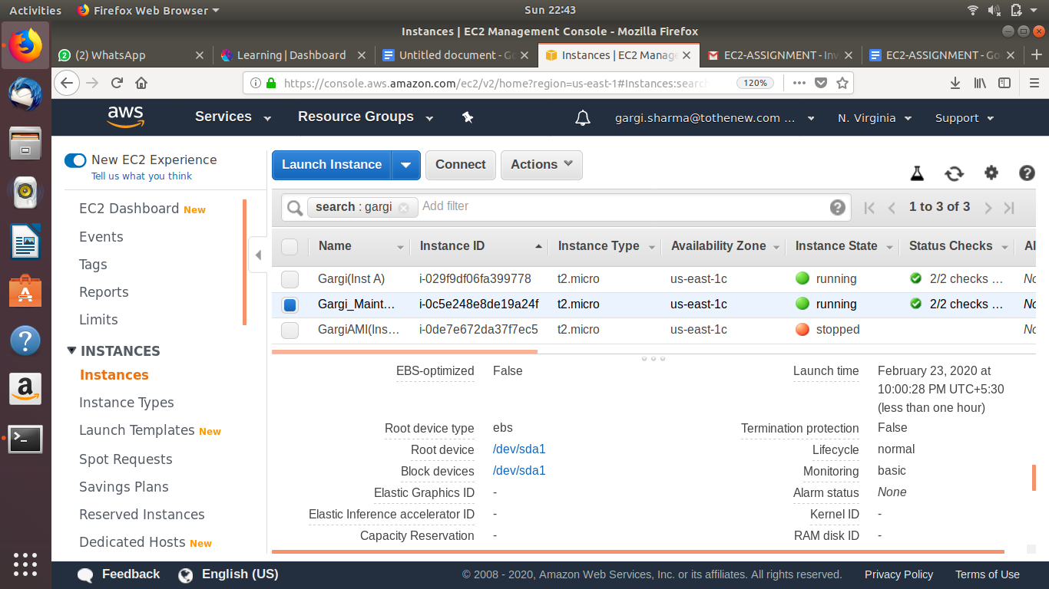

SSH to maintenance instance:

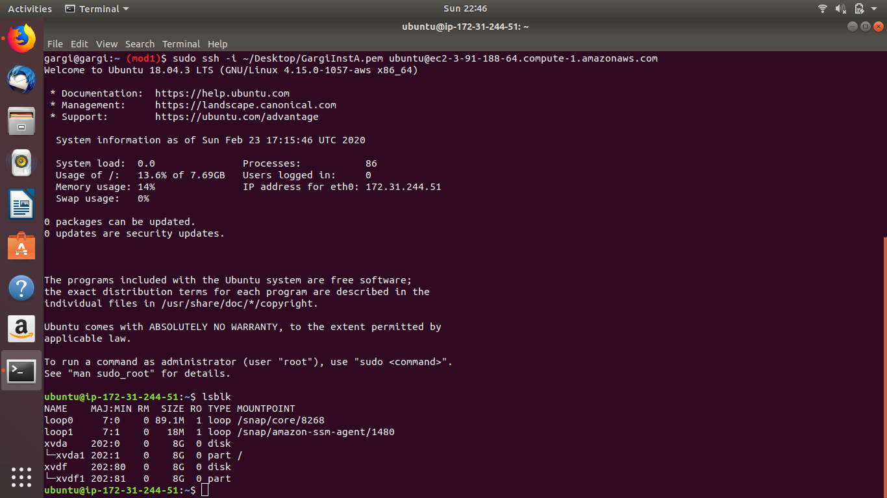

Create a filesystem and mount the partitioned EBS:

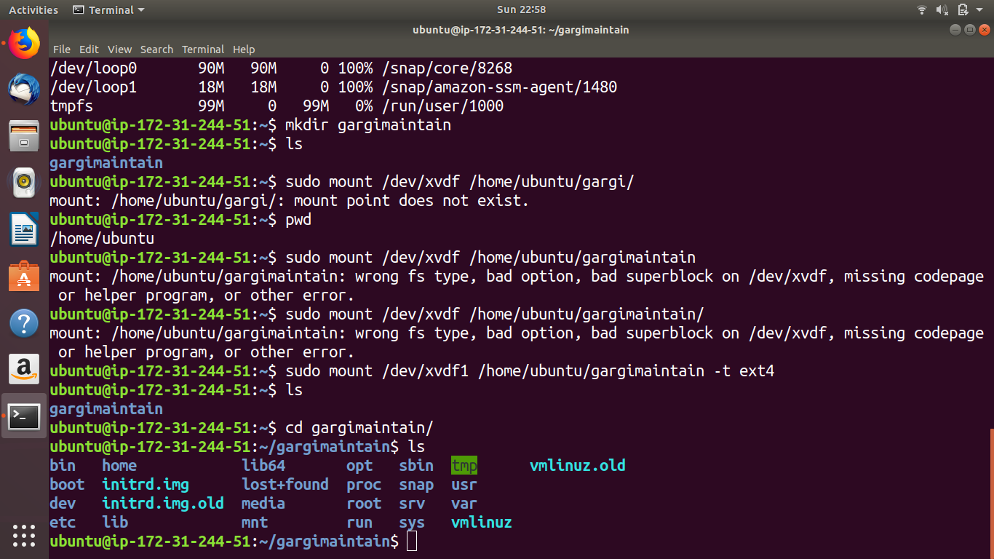

Open the /etc/fstab file and edit it properly:

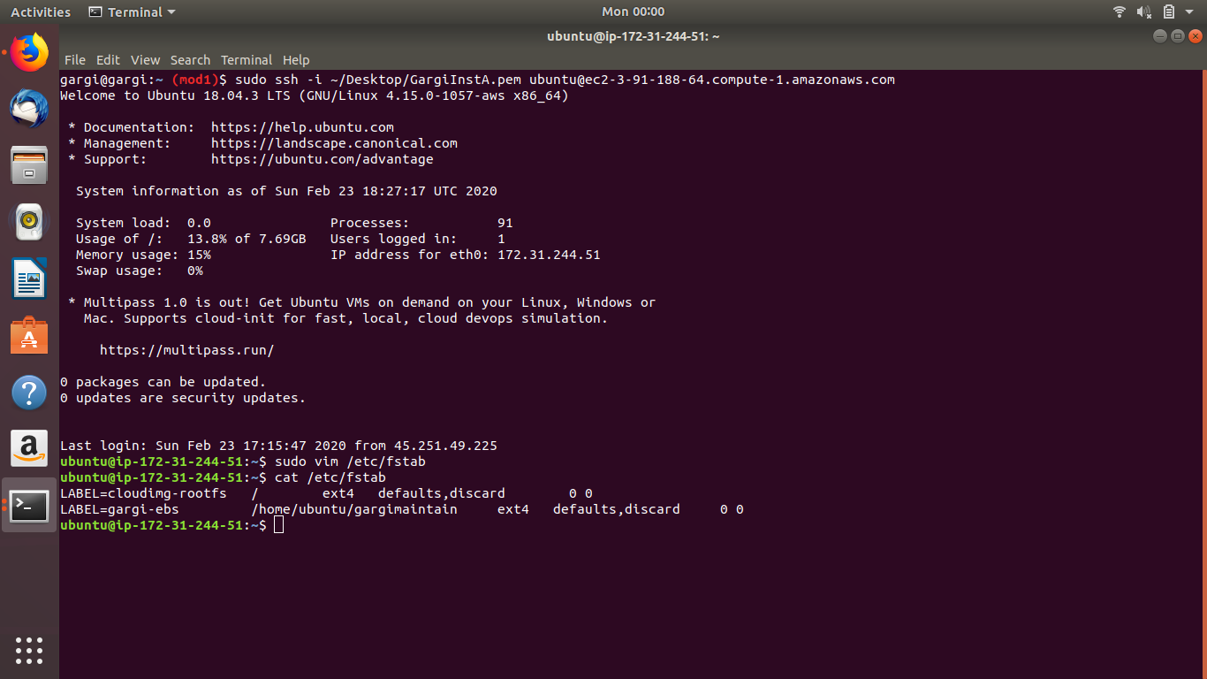

Detach and attach to the previous instance:

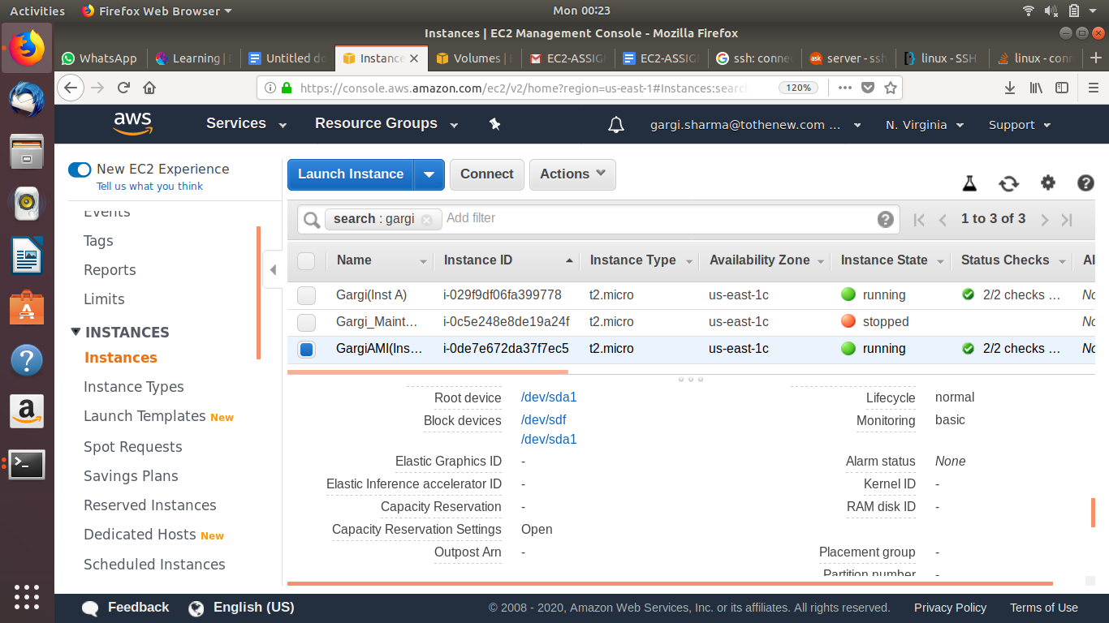

SSh into Instance B and check.

1. Resize the EBS from 8 to 10GB

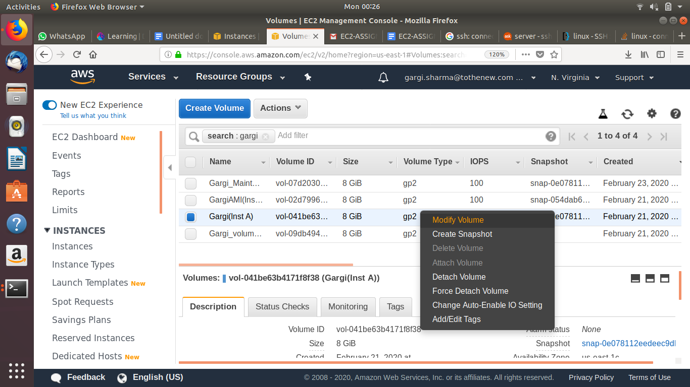

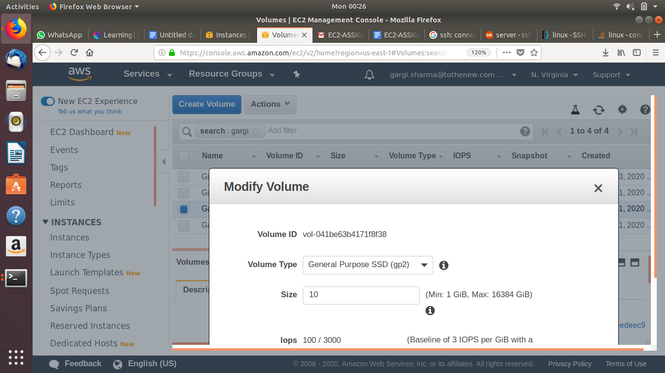

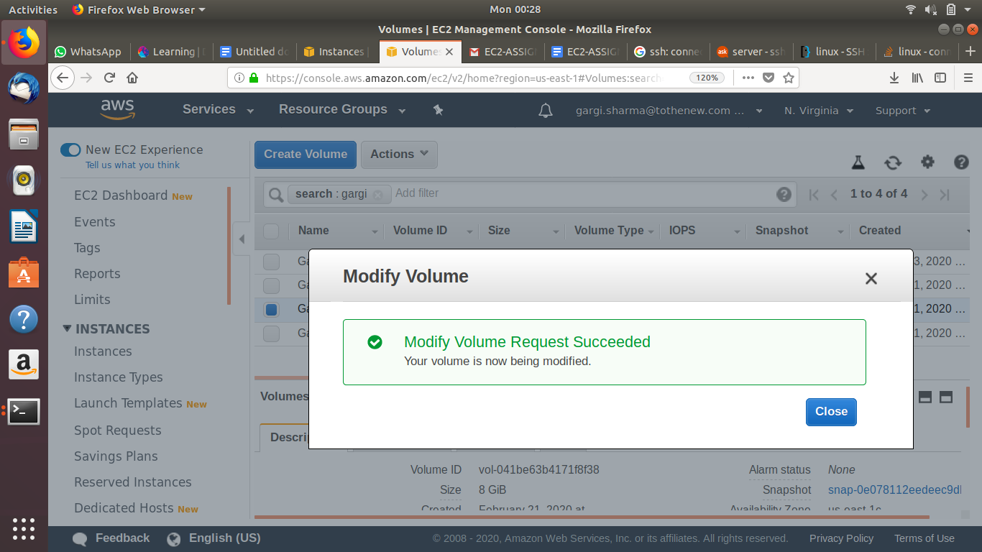

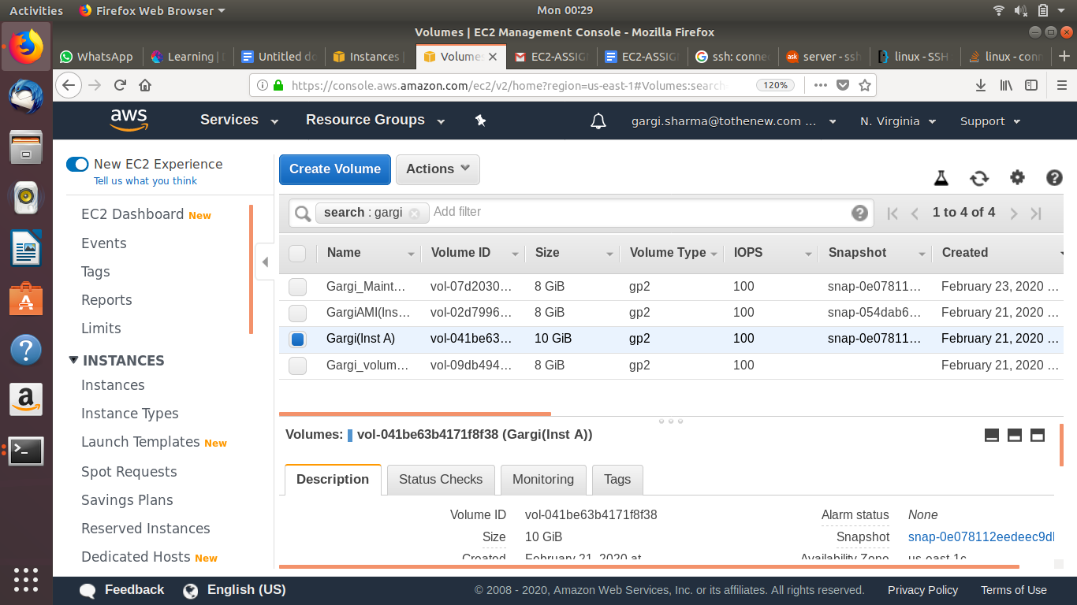

1. SSH from one instance A to instance B.

SSh to instance A from local host and execute ssh-keygen command. This will generate a key that you can save in your desired location:

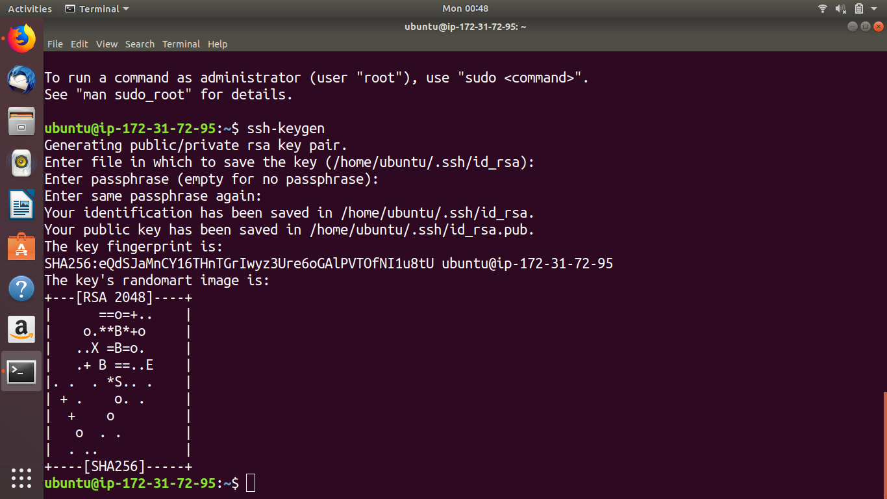

Paste the id_rsa.pub to /.ssh/authorised_keys and then

“ssh [ubuntu@ec2-52-204-206-83.compute-1.amazonaws.com](mailto:ubuntu@ec2-52-204-206-83.compute-1.amazonaws.com) “ from Instance A to Instance B.

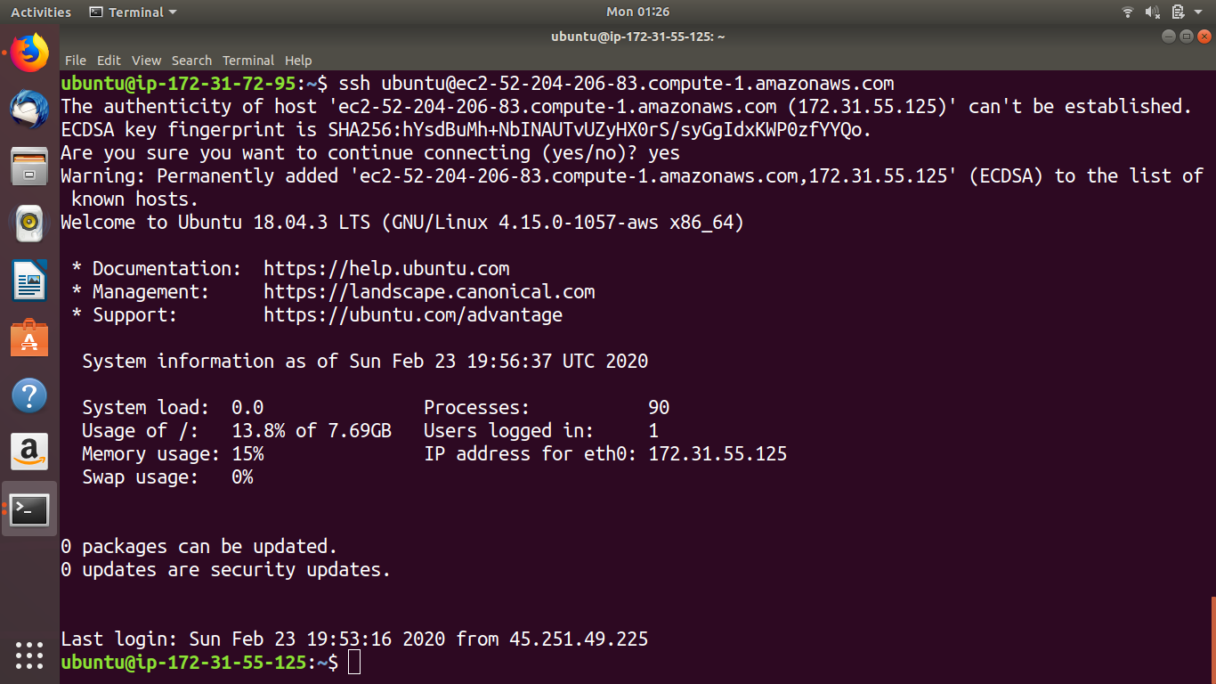

9. Deatach the root EBS, create its snapshot, than create the AMI and run it as instance such that nginx should be preinstalled at the boot time of instance.

Stop Instance B and detach the root volume.

Create snapshot for root volume of B.

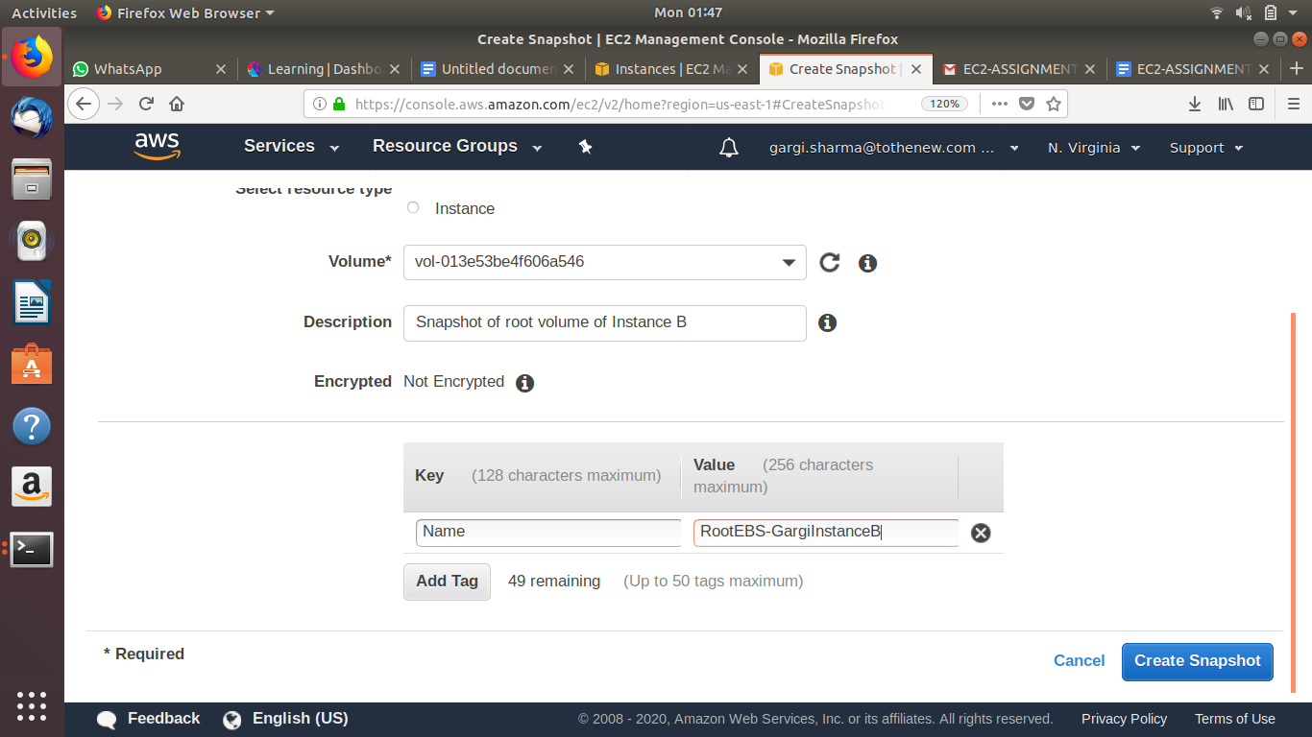

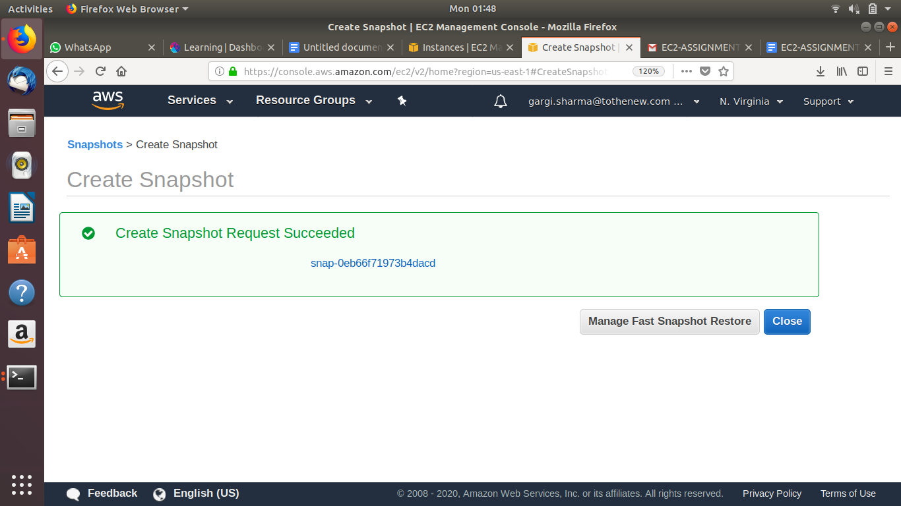

Create Image from the snapshot:

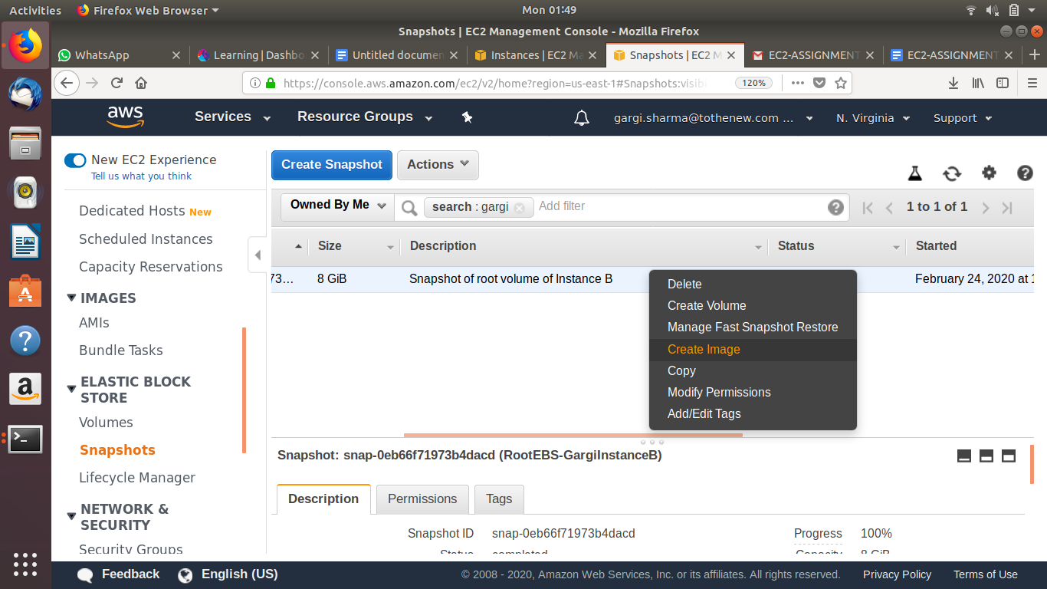

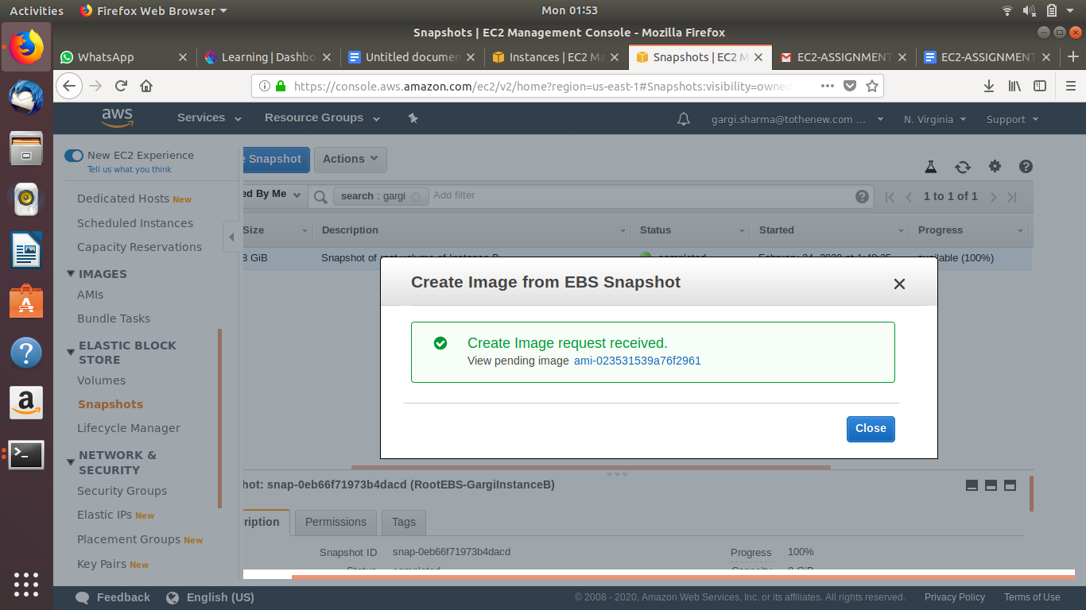

Launch an instance from the AMI and add user data so that nginx is installed at boot time:

User data:

**#!/bin/bash**

**Sudo apt-get update**

**Sudo apt-get install nginx**

**Sudo service nginx restart**

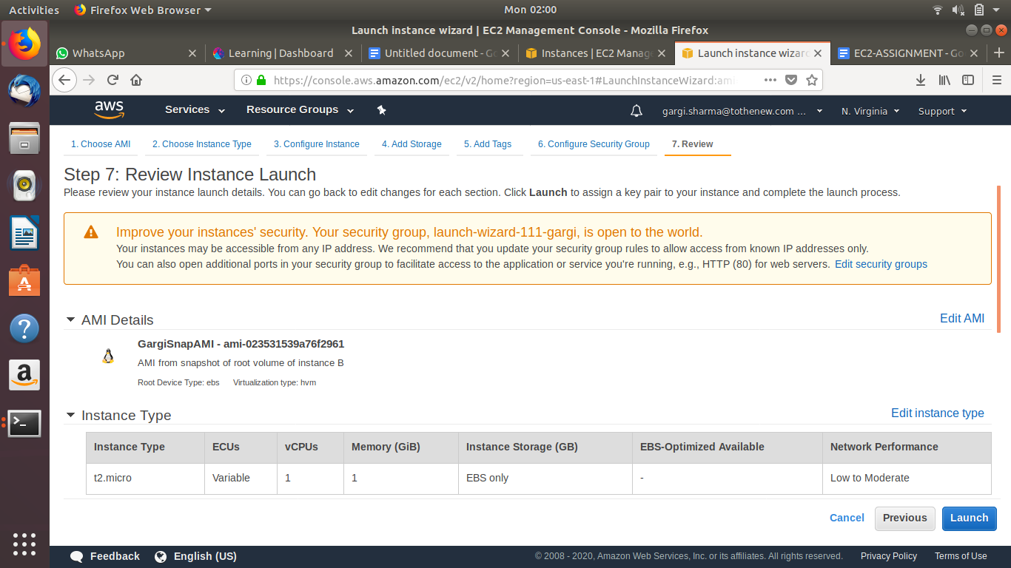

Once the instance is launched, ssh into the instance and chcek nginx status using “sudo service nginx status”

